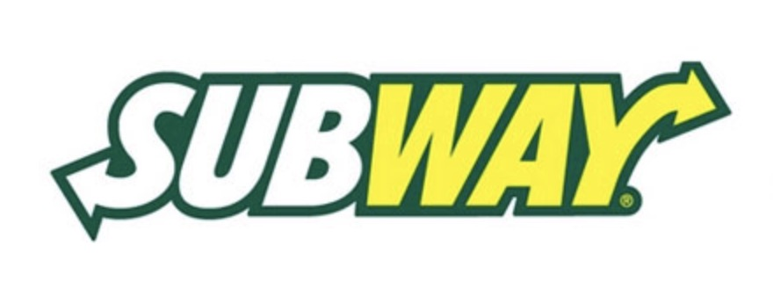  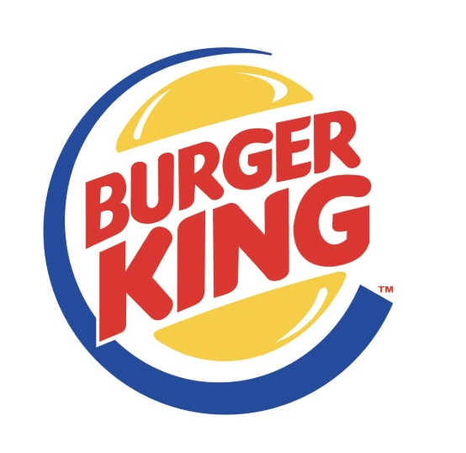  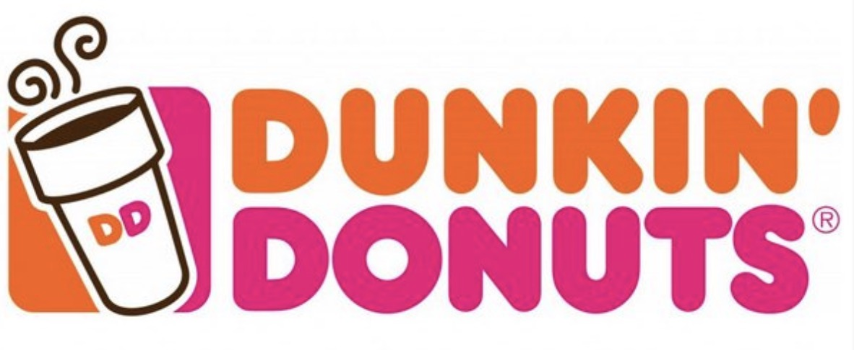  - RestauraNts  financing  Many restaurant owners simply don’t dream big because they can’t afford to borrow the funds they need.  Seize the next opportunity to expand your business with flexible financing.  Loan terms- from 1 to 3 years. Minimum credit score required- 551.  Startup businesses, bad credit is OK | Low rates, fixed payments, no hidden fees  ____  No collateral required on amounts up to $750K  ____  Tax deductible interests and early pay off options  ____  Instant approvals and funding in as little as 3 days  ____  Worldwide Capital Lending group  1820 N. Corporate Lakes Blvd Suite 306  Weston Fl 33326  954-645-7400  www.wwclg.com  Your name here  Cell:

