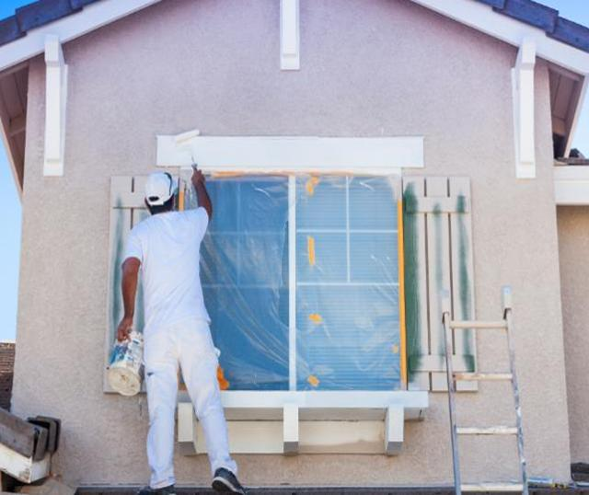  - fix & flip financing  investment properties  Residential Real Estate Investors  We offer investors the ability to purchase non-owner occupied properties, fix them and sell them immediately for a profit or just add them to your portfolio!  Rates for Fix and Flip start as low as 7.99% and Fix for Rental investments as low as 5%. | 100% Financing of Renovation Cost  ____  85% of Purchase Price  ____  Fix & Flip  ____  Fix for long term Rental rates as low as 5%  ____  Worldwide Capital Lending group  1820 N. Corporate Lakes Blvd Suite 306  Weston Fl 33326  954-645-7400  www.wwclg.com  Your Name Here  Cell:000-000-0000

