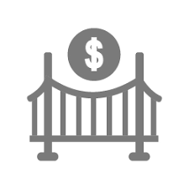

Your Name Here

Phone: 000-000-0000

Bridge and Hard Money Loan

We offer investors solutions for the scenario when they can’t get traditional financing and help them to acquire a commercial property, finish construction, or cash out on their commercial property assets.

Approval time: As fast as 24 hours

LTV: up to 75%

**Transaction Size:** $100,000 to 100,000,000

Prepayment: No prepayment penalties

[www.wwclg.com](http://www.wwclg.com)

Phone: 954-645-7400

Phone:

Custom Financing Solutions Beyond Your Bank

Bridge and Hard Money Loan